CPLS BC 3110
Professor Peter Connor (pconnor@barnard.edu)

INTRODUCTION TO TRANSLATION STUDIES

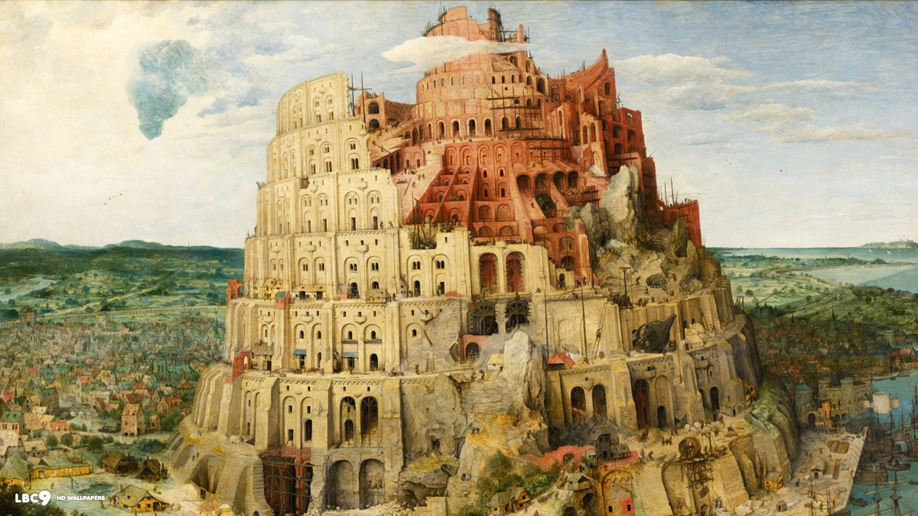
Pieter Bruegel the Elder, Tower of Babel, 1563. Kunsthistorisches Museum, Vienna.

Fall 2020
MW 2:40-3:55
Office hours: Monday 1:30-2:30 p.m.

Teaching Assistants
TBA

Description of course
This course will introduce students to the principal ways in which translation has been practiced and theorized in the Western tradition. We will consider, cultural, literary and philosophical theories of translation, as well as the role of translation and translators in today's globalized world. Topics covered will include: translation in the context of postcolonialism, globalization and immigration; the translation of children’s literature; subbing and dubbing in film and television, including fansubbing; translation and ecology; translation and justice; machine translation; linguistic rights; debates about mono- versus plurilingualism.

We will also consider, less extensively, the place of interpreting (i.e. oral translation primarily in legal and medical settings). Specialists from the New York area will come to speak about current needs and challenges in the field of community interpreting.

On the literary level, we will examine the role played by foreign languages (and translation) in the creative process of contemporary writers. We will read a number of “language memoirs,” narratives that recount the authors’ complex and sometimes agonized relation to acquiring a second language (Eva Hoffman, Xiaolu Guo, Alice Kaplan et al). For one of the assignments you will write the beginning of your own language history. We will also read and study in depth Brian Friel’s play Translations. This play is about the replacement of Irish (Gaelic) place names with English names as a result of an ordnance survey in the early 18th century.

The course aims to help students improve their translation skills by translating (mostly literature) from your second language (your L2, as the linguists call it) into English, by critically assessing published translations, and by evaluating each others' translations-in-progress (including one of the professor's).
There will be a number of guest lecturers (translators, editors, writers, interpreters etc).
KEYWORDS.
The course is loosely organized around a number of keywords, which serve to introduce the topic to be treated on any given day. Some examples of keywords I will be discussing are: Babel, barbarian, equivalence, linguicide, skopos, mother tongue, pundit, polyststem, snow, mimus polyglottis, shibboleth, untransatable, pundit, and koyaanisqatsi. All of these words relate in some way to the story of translation studies that I want to tell you over the course of the semester (you can perhaps guess that relation, at least for some of them). The idea is to build a lexicon of words that reference key issues in the field and that help us talk about those issues. I would like to create this discourse of translation together with you. Students will be invited to think of and contribute words that strike them as pertinent, and to offer the reasons.

This course is a foundational and required course for students wishing to complete a Translation Studies Minor. See http://complit.barnard.edu/node/43941 for details on the minor.

Prerequisite for the course
Intermediate or advanced level proficiency in any language other than English.
Learning objectives:
At the conclusion of this course, students will be:
- knowledgeable about the role of the various agents involved in the translation process (translator, author, editor, publisher, reviewer, reader etc)
- familiar with several different theories of translation
- conscious of the cultural and political stakes of language learning, and of current debates surrounding linguistic rights
- sensitive to language as a marker of identity and a factor in issues of cultural difference
- aware of the nature and significance of work performed by interpreters in medical, legal and political contexts

Assignments & Grading:
Assignment 1: Language Memoir (20%)
Assignment 2: Translation (20%) and written critique/appreciation of a peer translation (10%)
Final project: 35%
Class participation, 2-3 pop quizzes, submission of questions/comments to discussion board: 15%

Policy on Absences
Excused absences are granted on the grounds of illness, illness or death of a family member, and for major religious holidays. Except in emergency circumstances, please email one of the Teaching Assistants in advance of the course that you will miss.

ZOOM STATEMENT
The course will be conducted remotely via Zoom. Please use your real name on Zoom, and remain visible for the entire class. If you have a reason that you need to be invisible, please contact me by email to discuss this. The Chat function will be on, and can be used to ask questions or contribute comments.

Honor Code
Approved by the student body in 1912 and updated in 2016, the Code states:
We, the students of Barnard College, resolve to uphold the honor of the College by engaging with integrity in all of our academic pursuits. We affirm that academic integrity is the honorable creation and presentation of our own work. We acknowledge that it is our responsibility to seek clarification of proper forms of collaboration and use of academic resources in all assignments or exams. We consider academic integrity to include the proper use and care for all print, electronic, or other academic resources. We will respect the rights of others to engage in pursuit of learning in order to uphold our commitment to honor. We pledge to do all that is in our power to create a spirit of honesty and honor for its own sake.
Please note the following Addendum to Honor Code for 2020-2021:
We consider academic integrity to include the proper use and care for all print, electronic, or other academic resources.
To be clear, this means that any recorded class content — from lectures, labs, seminars, office hours, and discussion groups — is the intellectual property of your professor and your fellow students, and should not be distributed or shared outside of class.

Academic Integrity and Plagiarism
Any test, paper or report submitted by you and that bears your name is presumed to be your own original work that has not previously been submitted for credit in another course unless you obtain prior written approval to do so from your instructor.
In all of your assignments, including your homework or drafts of papers, you may use words or ideas written by other individuals in publications, web sites, or other sources, but only with proper attribution. “Proper attribution” means that you have fully identified the original source and extent of your use of the words or ideas of others that you reproduce in your work for this course, usually in the form of a footnote or parenthesis.
In all activities relating to this class you are expected to respect the Barnard Honor Code: http://barnard.edu/dos/honorcode.
For assignments involving translation, do not use Google Translate or any other translation software, unless I have authorized you to do so.

Center for Accessibility Resources & Disability Services (CARDS) Statement
If you believe you may encounter barriers to the academic environment due to a documented disability or emerging health challenges, please feel free to contact me and/or the Center for Accessibility Resources & Disability Services (CARDS). Any student with approved academic accommodations is encouraged to contact me during office hours or via email. If you have questions regarding registering a disability or receiving accommodations for the semester, please contact CARDS at (212) 854- 4634, cards@barnard.edu, or learn more at barnard.edu/disabilityservices. CARDS is located in 101 Altschul Hall.
Affordable Access to Course Texts & Materials Statement
All students deserve to be able to study and make use of course texts and materials regardless of
cost. Barnard librarians have partnered with students, faculty, and staff to find ways to increase
student access to textbooks. By the first day of advance registration for each term, faculty will
have provided information about required texts for each course on CourseWorks (including ISBN
or author, title, publisher, copyright date, and price), which can be viewed by students. A number
of cost-free or low-cost methods for accessing some types of courses texts are detailed on the
Barnard Library Textbook Affordability guide (library.barnard.edu/textbook-affordability).
Undergraduate students who identify as first-generation and/or low-income students may check
out items from the FLIP lending libraries in the Barnard Library (library.barnard.edu/flip) and in
Butler Library for an entire semester. Students may also consult with their professors, the Dean of
Studies, and the Financial Aid Office about additional affordable alternatives for having access to
course texts. Visit the guide and talk to your professors and your librarian for more details.

Wellness Statement
It is important for undergraduates to recognize and identify the different pressures, burdens, and stressors you may be facing, whether personal, emotional, physical, financial, mental, or academic. We as a community urge you to make yourself--your own health, sanity, and wellness- -your priority throughout this term and your career here. Sleep, exercise, and eating well can all be a part of a healthy regimen to cope with stress. Resources exist to support you in several sectors of your life, and we encourage you to make use of them. Should you have any questions about navigating these resources, please visit these sites:
http://barnard.edu/primarycare
https://barnard.edu/about-counseling
http://barnard.edu/wellwoman/about
Stressbusters Support Network

Books
Lawrence Venuti (ed.), The Translation Studies Reader (3rd ed. 2012)
Brian Friel, Translations
You are encouraged to read as widely as possible in the Translation Studies Reader. The essays in the volume are foundational texts of the discipline of translation studies; reading any one of them will greatly increase your knowledge of the field. I will assign only some of them formally, but all are interesting and helpful.
Texts not found in the Reader (indicated below by an asterisk*) are available through Courseworks (under “Files and Resources”). The bibliographical references for these essays can be found in the file “Bibliography: Required and Optional Readings,” also on Courseworks.
READINGS
Note: You should read all the readings assigned for the week before the Monday class.

Week I (9 September): Babel (in the beginning…)
*Genesis 11 : 1-9 (Tower of Babel)
*Hugo Friedrich, "On the Art of Translation"
Roman Jakobson, "On Linguistic Aspects of Translation"

Week II (14 and 16 September): Reading Literature in Translation
Friedrich Nietzsche, "Translations"
*A. Schopenhauer, "On Language and Words"
Week III (21 and 23 September): (So-called) Mother Tongues (native tongues, first languages, cradle languages, given languages, L1s etc)
*Eva Hoffman, Lost in Translation (ext.)
*Alice Kaplan, French Lessons (ext.)
*Xialou Guo, A Concise Chinese-English Dictionary for Lovers (ext.)
*Amy Tan, "Mother Tongue"
Week IV (28 and 30 September): Language Memoirs
*Evelyn Nien-Ming Ch'ien, Weird English (ext.)
Nurith Aviv, Misafa Lesafa (film). Extracts (Intro sequence; Agi Mishol)
In class activity: “Identifications”
*Edward Sapir, "The Grammarian and his Language"
*Basel Al-Sheikh Hussein, "The Sapir-Whorf Hypothesis Today"
Week V (5 and 7 October): Foreigniziation and Domestication
Antoine Berman, “Translation and the Trials of the Foreign"
*W. von Humboldt, "Introduction" to his translation of Agamemnon
*Alice Kaplan, "Translation: the Biography of an Art Form"
October 5: Assignment 1 due.

Week VI (12 and 14 October): Translation and cultural difference
Tuesday 9 October: Friedrich Schleiermacher, “On the Different Methods of Translating”

Week VII (19 and 21 October):
*Susan Bernofsky, “Translation and the Art of Revision”
*Lawrence Venuti, “Translating Jacopone da Todi”
Eliot Weinberger, "Anonymous Sources (On Translators and Translation)"

Week VIII (26 and 28 October): Constraints; OULIPO, the translation of children's literature
Gillian Lathey, "Meeting the Unknown: Translating Names, Cultural Markers, and and Intertextual References" (from Translating Children's Literature)
*Zohar Shavit, "Translation of Children's Literature" (from Poetics of Children's Literature)
*Raymond Queneau, Exercises in Style (ext.)

Week IX (Wednesday 4 November): Subtitling: an historical example
*Tessa Dwyer, “Universally Speaking: Lost in Translation and polyglot cinema”
J-L Godard, dir., Le Mépris (Contempt). Film (extract in class)
+ In class discussion of peer translations
Assignment 2 due at end of 4 November class

Week X (9 and 11 November):
J-L. Borges, "The Translators of the Thousand and One Nights"
*J. L. Borges, "An English Version of the Oldest Songs in the World

Week XI (16 and 18 November): Translation and Colonialism
*Chinua Achebe, “The African Writer and the English Language”
*Ngugi wa Thiong’o, “The Language of African Literature”
Brian Friel, Translations

Week XII (Monday 23 November): Translation and Literature
Brian Friel, Translations

[Wednesday 25 November-Sunday 29 November: Thanksgiving vacation]

Week XIII (30 November and 2 December): Interpreting
*Routledge Encyclopedia of Translation, "Community Interpreting"
*Michael Cronin, "Babel Átha Cliath: The Languages of Dublin"
*”Universal Declaration on Linguistic Rights”
*”424 F2d 386 United States Negron v. State of New York”
[in class] Excerpt from film Dirty Pretty Things (Stephen Frears, dir.)

Week XIV (7 and 9 December): Conquest, Asylum
*Camilla Townsend, Malintzin's Choices: An Indian Woman in the Conquest of Mexico (ext.)
*Valeria Luiselli, Tell Me How It Ends. An Essay in Forty Questions, ch. 2 ("Court")

Week XV (Monday 14 December): Conclusions

Final project due 9 December

N.B. SYLLABUS IS PROVISIONAL—SUBJECT TO CHANGE

