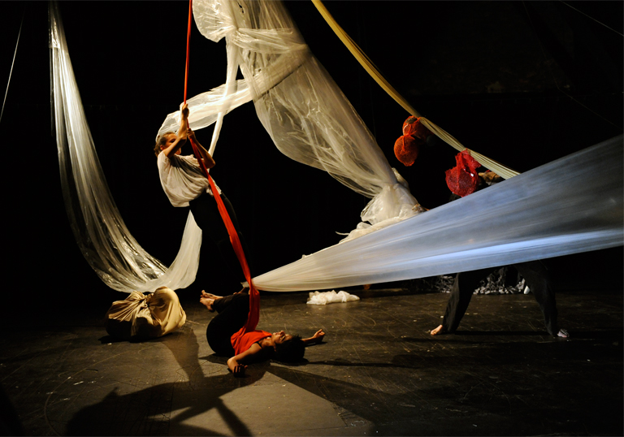
Theater of the Viscera

TRAGIC BODIES
CPLS 3160 MW 2:40-3:55 Classroom TBA
Nancy Worman
(nworman@barnard.edu)

What do bodies mean? How do bodies in extremis shape the way we understand identity —from the bloody Oedipus in the ancient Theater of Dionysus to the black bodies colonized in Jordan Peele's 2017 film Get Out? How does dramatic enactment distinguish bodies by gender and sexuality, race and class, or as human versus monstrous or divine? “Tragic bodies” are outsider bodies, on and off the stage—debased, denigrated, cast off. But they also exert a powerful attraction, as riveting other selves.
This course will focus on embodiment in ancient and modern drama as well as in film, television, and performance art, including plays by Sophocles, Shakespeare, and Beckett; films such as Roman Polanski's Rosemay's Baby and Jim Jarmusch's Only Lovers Left Alive; and performances by artists such as Lorraine O'Grady, David Wojnarowicz, and Marina Abramovic. We will explore the provocations, theatricality, and shock aesthetics of such concepts as Antonin Artaud’s “Theater of Cruelty,” Julia Kristeva's "powers of horror," Donna Haraway's "post-gender cyborgs," and Saidiya Hartman's "stage of sufferance."

