**Overview of Workday Tasks, Reports, and Grant Financial Reports**

**December 2022**

**Barnard College**

**Links to Workday Job Aids**

**Hiring:**

* [**Recruiting and Hiring Overview**](https://www.myworkday.com/barnard/d/inst/4de2a352671c010207d83df2c3950000/rel-task/2998$40834.htmld)
* [**Recruiting and Hiring Staff**](https://www.myworkday.com/barnard/d/inst/ac8ef4686bff0100b7a3557ec19a0000/rel-task/2998$40834.htmld)
* [**Staff Hiring Process Overview**](https://www.myworkday.com/barnard/d/inst/10d2242480580101ebf0364c47a80000/rel-task/2998$40834.htmld)
* [**Add Academic Appointment**](https://www.myworkday.com/barnard/d/inst/789c2a38055001237c177b1d5a8c0000/rel-task/2998$40834.htmld)
* [**End Academic Appointment**](https://www.myworkday.com/barnard/d/inst/789c2a38055001237edd6a32a1500000/rel-task/2998$40834.htmld)
* [**Hiring Adjuncts, TAs, and Graders**](https://www.myworkday.com/barnard/d/inst/7a6b4c921a6410010a2c05a2ddc20000/rel-task/2998$40834.htmld)

**Purchasing and Procurement:**

* [**Create Supplier Invoice Request (Check Request)**](https://www.myworkday.com/barnard/d/inst/84c99bf792e5010077d8d36d670f0000/rel-task/2998$40834.htmld)**: this task should be used to submit requests to pay for contracted and invoiced goods and services totaling $500.00 or less *or* to submit subrecipient invoices for payment, regardless of the dollar amount.**
* [**Create Requisition**](https://www.myworkday.com/barnard/d/inst/b6ca5ec094f8010105425b1f51620000/rel-task/2998$40834.htmld)**: this task should be used for the creation of a purchase order, which one needs to pay contracted and invoiced goods and services over $500.00. Fully executed agreements need to uploaded to Workday when creating a requisition.**
* [**Create Expense Report (Citizens Bank Expense Card)**](https://www.myworkday.com/barnard/d/inst/b6ca5ec094f80100fd3a4239f8d90000/rel-task/2998$40834.htmld)**: expense card (called p-card pre-Workday) transactions are no longer reconciled in CentreSuite; they’re now reconciled in Workday. This is a link to the College’s** [**payment transactions policy**](https://portal.barnard.edu/sites/default/files/2021-06/Payment%20Transactions%20Policy.pdf)**.**

**Expense Reimbursement:**

* [**Create Expense Report (Expense Reimbursement)**](https://www.myworkday.com/barnard/d/inst/e1918265d99e010068a749f530040000/rel-task/2998$40834.htmld)**: expenses paid for out of pocket, with a credit card other than a College-issued Citizens Bank MasterCard, need to be submitted for reimbursement using the** [**Create Expense Report**](https://www.myworkday.com/barnard/d/task/2997$995.htmld) **task. Reimbursements are subject to the College’s** [**expenditure**](https://portal.barnard.edu/sites/default/files/2021-05/Expenditure%20Policy%20FY20.pdf) **and procurement policies.**

**Grant Financial Reports:**

* [**RPT007: Award Life to Date (LTD) - Budget vs Actual**](https://www.myworkday.com/barnard/d/task/1422$303.htmld)**: type the six-digit Barnard program number into the ‘Grant’ field, leave all other fields at their defaults, and click OK:**

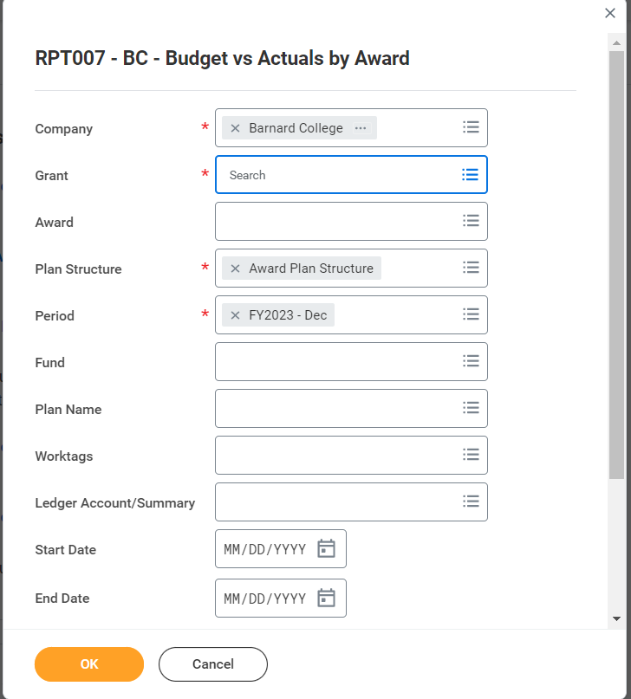

**This report will provide the faculty member or other authorized staff member (such as a department administrator or assistant) with a snapshot of the following grant information:**

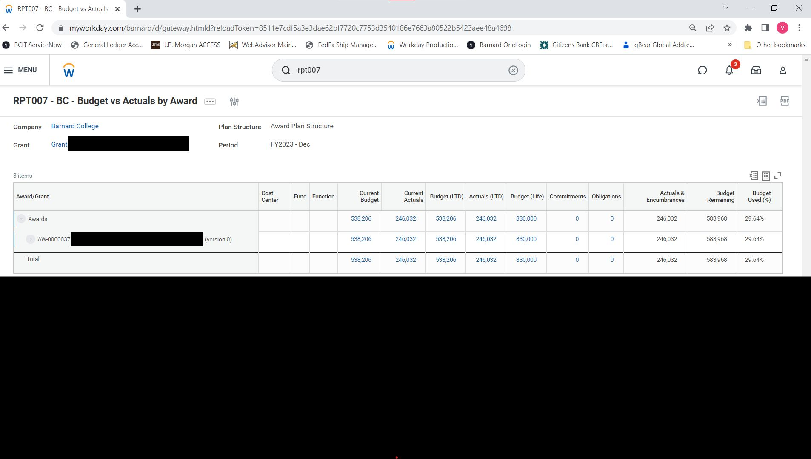

* + **Current Budget: the budget for the current fiscal year;**
  + **Current Actuals: expenditures for the current fiscal year to date;**
  + **Budget (LTD): the sum of the budget for every budget year of the award, including the current budget period;**
  + **Actuals (LTD): expenditures incurred every budget year to date;**
  + **Budget (Life): the total award;**
  + **Commitments: the sum of purchase requisitions;**
  + **Obligations: the sum of purchase orders;**
  + **Actuals & Encumbrances: expenditures incurred plus funds set aside for purchase orders;**
  + **Budget Remaining: the funds available; and**
  + **Budget Used (%): the actuals and encumbrances, noted as a percentage.**

**All information in blue type is a hyperlink one can click on for more information.**

* [**RPT025: Grant Activity Summary (NEW)**](https://www.myworkday.com/barnard/d/task/1422$826.htmld)**: this report provides the faculty member or other authorized staff member with a summary of externally-funded grant expenditures (actuals).**

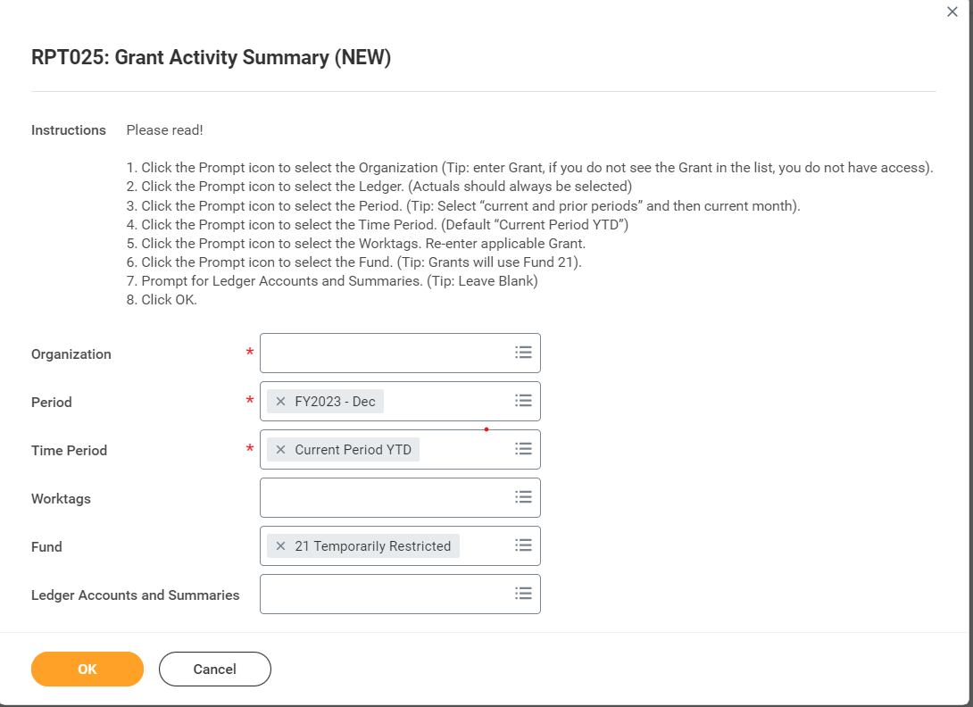

**Rather than following the instructions in the screenshot, I suggest making the following modifications:**

* + **Organization: enter the six-digit Barnard program number (beginning with a 1 or 4);**
  + **Period: choose the current fiscal year and current month, as instructed;**
  + **Time Period: choose “Last 36 Periods” instead of “Current Period YTD”;**
  + **Worktags: enter the six-digit Barnard program number again;**
  + **Fund: choose 21, as instructed;**
  + **Ledger Accounts and Summaries: choose “Ledger Account Summary”, then check off “Barnard Parent Account Set: Expenses” and “Barnard Parent Account Set: Net Assets”.**

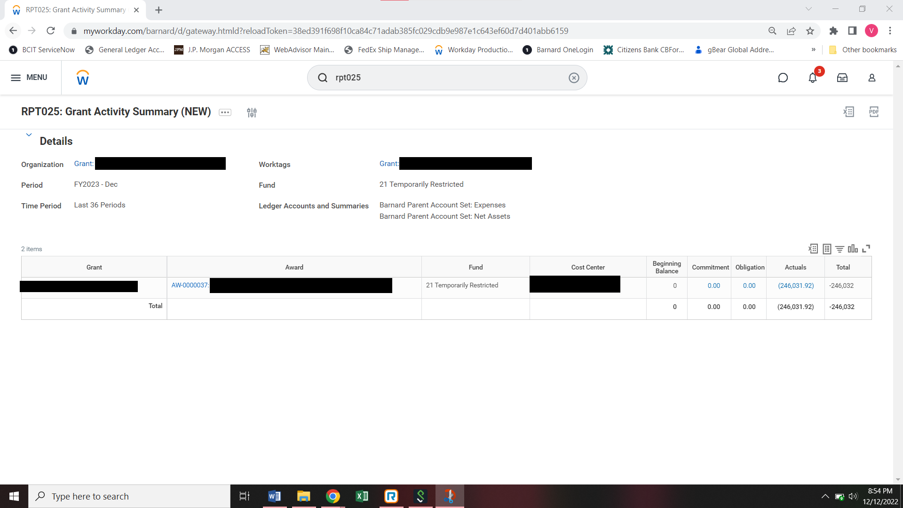

**The actuals should match the actuals one sees in RPT007.**

***Please keep in mind expenses for externally-funded grants awarded before Fiscal Year 2020 (which began July 1, 2019 and ended June 30, 2020) were not uploaded to Workday. For expenses predating FY20 (i.e., expenses incurred in FY19 and earlier), please log on to WebAdvisor for that data. Victoria Toro (email: vtoro@barnard.edu) can also help you retrieve that information.***

* [**RPT027: Restricted Program Balance Summary (NEW)**](https://www.myworkday.com/barnard/d/task/1422$815.htmld)**: this report provides the faculty member or other authorized staff member with a summary of internally-funded grant expenditures (actuals).**

**The instructions, as provided in the screenshot below, will provide expenses, life to date, for one’s internally-funded grant (e.g., faculty research grant, cost-share (indirect cost recovery account), start-up grant):**

