Women, Sex & Power in 17th Century French Literature  Instructor: Séverine C. Martin  Office Hours: by appointment  sm1153@columbia.edu | Spring 2021  M-W: 11:00am-12:15pm



COURSE DESCRIPTION
When thinking of 17th Century France, we tend to focus on the all-encompassing figure of Louis XIV, Roi Soleil. However, the 17th Century was also the century of women: women writers, women philanthropists, and women intellectuals who led some of the most influential literary salons of their time. The presence and agency of women during that period had a major influence on the representation of women in literature. Between heroic idealizations and caricatural portrayals, this course will attempt to discern between these two extremes to form an image of the real contribution of women to the literature of this period.

COURSE PREREQUISITES
Enrollment into this course is open to all students who have satisfied their French language requirement.

STUDENT LEARNING OUTCOMES
At the conclusion of this course, students will have gained:
- A more comprehensive view of 17th Century French literature through the study of different literary genres (poetry, drama, prose)
- A better understanding of the literary and historical contribution of women to that period through a broad overview of the major female figures of the time
- Insight into the struggles and successes of defining the female voice within a patriarchal society
- Refined tools and methods for analyzing literary texts through several close readings & oral presentations

COURSE TEXTS

Excerpts provided in an online course pack

Primary Sources:
- Madame de La Fayette, Portrait de la marquise de Sévigné, par Madame la comtesse de la Fayette, sous le nom d’un inconnu in Recueil des portraits, Madame de Montpensier (1659)
- La Fontaine, Les Fables (1668)
- ETA Hoffmann, Mlle de Scudery: Chronique Du Temps de Louis XIV (1894)
- Madame de Sévigné, Lettres (1725)
- Voltaire, Le Siècle de Louis XIV (1751)

Secondary Sources :
- Juliette Benzoni, Ces femmes du Grand Siècle (2015)
- Rocher Duchêne, Être femme sous Louis XIV (2004)
- Antonia Fraser, Les Femmes dans la vie de Louis XIV (2009)

Full texts – books to be purchased by students (exact references will be published on Canvas)

- Corneille, Le Cid (1637)
- Madame de Lafayette, La Princesse de Clèves (1678)
- Molière, Les Précieuses ridicules (1659)
- Molière, Le Misanthrope (1666)

COURSE POLICIES AND REQUIREMENTS
- Attendance and Punctuality. Attendance is vital for the success of this course. If you need to be absent from class because of an important matter, e.g., medical emergencies, illness or death of a family member, major religious holidays, please let me know in advance by e-mail. A pattern of absences or tardiness will lower your final participation grade.
- Preparation and Active Reading and Participation. You are expected, of course, to have read the assignment carefully by the day it is scheduled for discussion. Don’t forget to bring copies of the reading to class. Be prepared to share your questions and ideas with the class and to engage actively with one another’s questions and comments. Students will be regularly required to give in-class presentations. 3 of them will be graded.

COURSE EVALUATION

Your final grade will be determined on the following basis:

- Participation: 15%
- 3 oral presentations: 30%
- 4 close readings (2-3 pages): 20%
- Final paper (7-10 pages): 35%

ACCOMMODATION OF DISABILITY

Students with a documented disability may be eligible for academic accommodations. If you have a documented disability, please let your instructor know as early as possible in the semester so that arrangements for accommodations may be made in advance. Please note that you are required to register in advance with the Office of Disability Services. (For more information, go to http://barnard.edu/disabilityservices (Links to an external site.). )

ACADEMIC INTEGRITY

You are expected to be familiar with the codes governing plagiarism and standards of academic integrity as detailed in the Barnard College Honor Code. (For the text of the Honor Code, go to: http://barnard.edu/dos/honorcode (Links to an external site.). )Any failure to uphold these standards of academic integrity will carry severe consequences
COURSE SCHEDULE

Week 1 (January 11)  Session 1  Session 2 | Introductory Session  Overview of course syllabus, readings and expectations  Women in the siècle of Louis XIV  Overview on the situation of women during the Ancien Régime  Required readings :  Juliette Benzoni, Ces femmes du Grand Siècle, éd. Perrin, 2015 - selected passages  Rocher Duchêne, Être femme sous Louis XIV, éd. Perrin, 2004 - selected passages  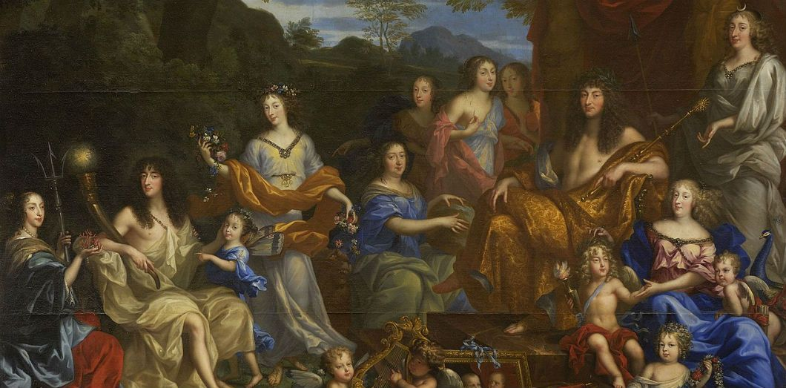  Louis XIV et la famille royale, tableau de Jean Nocret (1670)  Château de Versailles

Week 2 (January 18)  Session 1  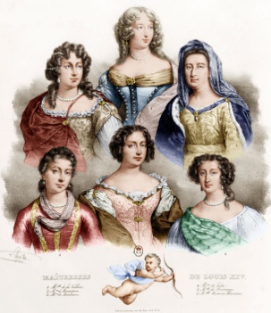  Session 2 | Sex & Power under Louis XIV  Royal mistresses  - Marquise de Montespan  - Madame de Maintenon  Required readings :  Le Siècle de Louis XIV, Voltaire (1751) – Chapiter I & selected passages  Film screening:  L’Allée du roi, Nina Companeez (1995) – selected passages will be studied in class  Elles ont régné sur Versailles, Secrets d’Histoire – available on Youtube  Intellectuals  - Madame de La Fayette  - Madame de Sévigné  Required readings :  Le Siècle de Louis XIV, Voltaire (1751) – selected passages  Madame de La Fayette, Portrait de la marquise de Sévigné, par Madame la comtesse de la Fayette, sous le nom d’un inconnu in Recueil des portraits, Madame de Montpensier (1659).

Week 3 (January25)  Session 1  Session 2 | Women in the life and work of La Fontaine  Women patrons and women figures in Les Fables (1668-1694)  La Fontaine’s women patrons:  - Marie-Anne Mancini  - Marguerite de Lorraine  - Madame de la Sablière  Required readings :  « A Mme de Montespan » ; « Discours à Mme de La Sablière » in Les Fables (1668-1694)  Group presentations on selected passages  Required readings :  « Les deux maîtresses » ; « La femme noyée » ; « Le mal marié » ; « La Fille » ; « Les femmes et le Secret » ; « La Laitière et le Pot au lait » ; « Les obsèques de la lionne » ; « Les Filles de Minée » ; « L’Ivrogne et sa Femme » ; « La Jeune Veuve » ; « Joconde » ; « Le Mal Marié » ; « La Matrone d’Éphèse » ; « La Chatte métamorphosée en Femme” ; « La courtisane amoureuse » ; « Les Devineresses » ; « L’écrevisse et sa Fille » ; « L’Éducation » ; « La Femme noyée » ; La Fiancée du roi de Garbe » ; « La Souris métamorphosée en Fille » in Les Fables (1668-1694)

Week 4 (February 1)  Session 1  Session 2 | Précieuses et préciosité  Definition of an intellectual and literary movement  Female protagonists of Madame de Scudéry’s literary salons and novels  Required readings:  Mlle de Scudery: Chronique Du Temps de Louis XIV, ETA Hoffmann (1894) – selected passages

Week 5 (February 8)  Session 1  Session 2 | From Madame de Scudéry’s literary salons to Molière’s précieuses ridicules  Introducing Molière  Required film for in-class discussion:  Molière, Ariane Mnouchkine (1978)  Required readings:  Les Précieuses ridicules, Molière (1659) – scenes I-IX

Week 6 (February 15)  Session 1  Session 2 | Les précieuses sont-elles ridicules ?  Required readings:  Les Précieuses ridicules, Molière (1659) – scenes X-XV  Required readings:  Les Précieuses ridicules, Molière (1659) – scenes XVI-XVII  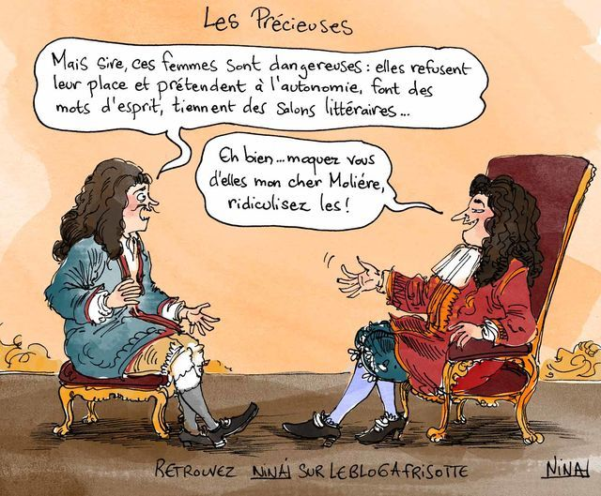

Week 7 (February 22)  Session 1  Session 2 | Introduction to Corneille & the Corneillian hero  Required readings:  Le Cid, Corneille – Acte I  Required readings:  Le Cid, Corneille – Acte II

Spring break

Week 8 (March 8)  Session 1  Session 2 | Corneillian heroines: Chimène & L’Infante  Required readings:  Le Cid, Corneille – Actes III-IV  Required readings:  Le Cid, Corneille – Acte V

Week 9 (March 15)  Session 1  Session 2 | Introducing the female psyche in the novel  La Princesse de Clèves, Madame de Lafayette - Première Partie  La Princesse de Clèves, Madame de Lafayette - Seconde Partie

Week 10 (March 22)  Session 1  Session 2 | Introducing the female psyche (continued)  La Princesse de Clèves, Madame de Lafayette – Troisième Partie  La Princesse de Clèves, Madame de Lafayette – Quatrième Partie

Week 11 (March 29)  Session 1  Session 2 | Madame de Sévigné  Representations of women in public life  Required readings :  Study of selected passages of letters by Madame de Sévigné  Marriage, women and the domestic sphere  Required readings :  Study of selected passages of letters by Madame de Sévigné

Week 12 (April 5)  Session 1  Session 2 | Célimène, or a new conception of female emancipation  Le Misanthrope, Molière – Actes I-II  Le Misanthrope, Molière – Actes III

Week 13 (April 12)  Session 1  Session 2 | Célimène, or a new conception of female emancipation (continued)  Le Misanthrope, Molière – Actes IV  Le Misanthrope, Molière – Acte V

